Life story workshop

Phases

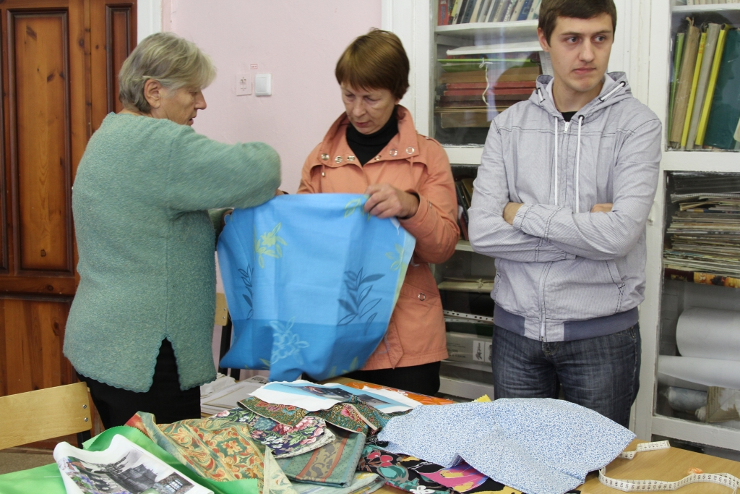

1. Memorise!

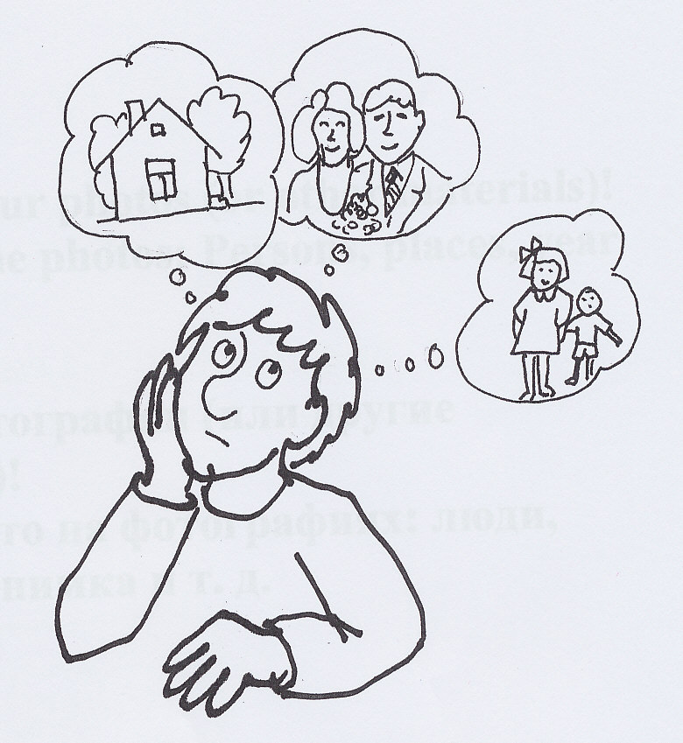

2. Tell!

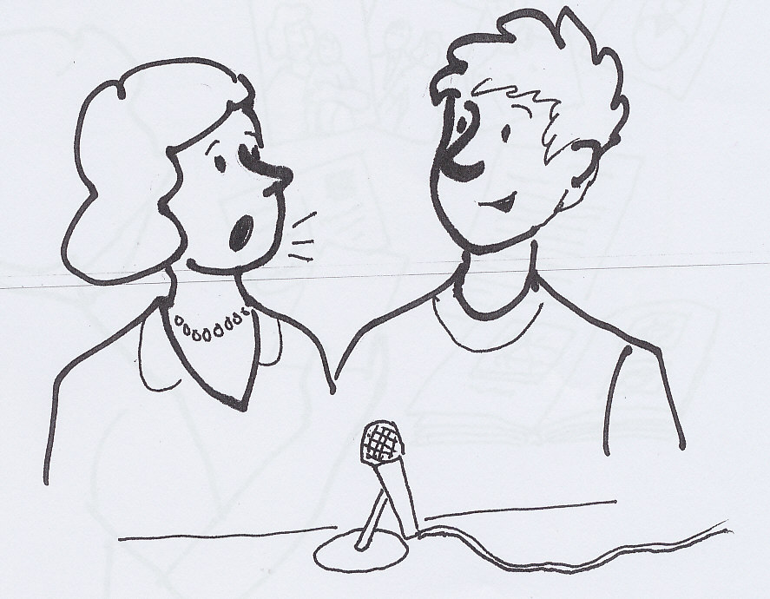

3. Choose your photos (or other materials)!
Tell about the photos: Persons, places, year etc.)

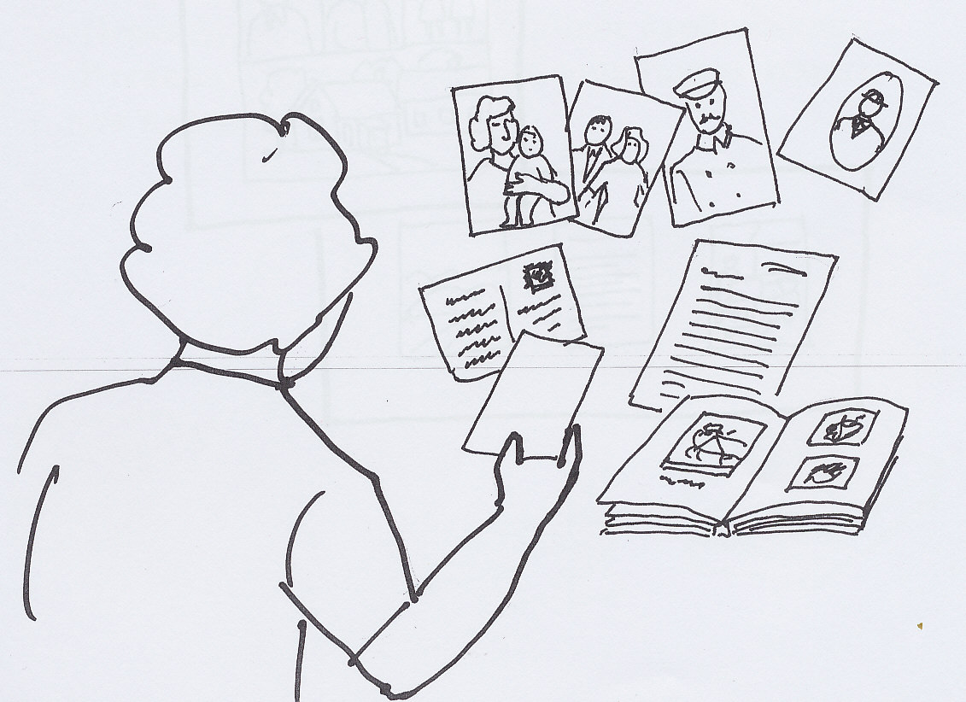

4. Plan a composition (collage) of 1-6 pictures! The teachers will help.

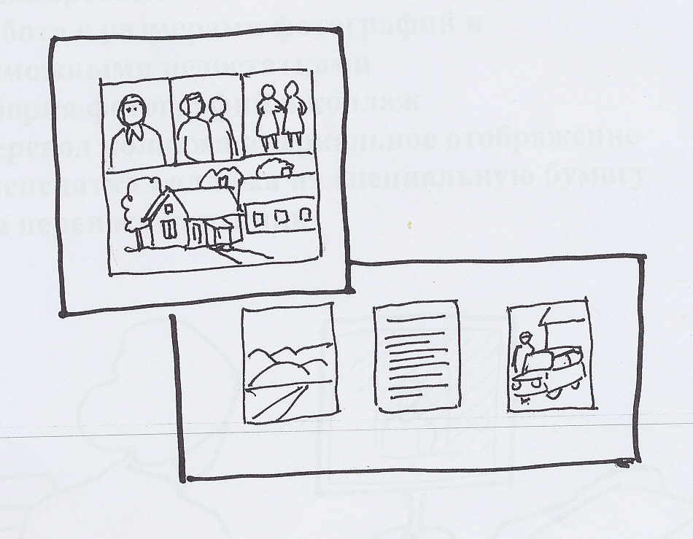

5. Computer work (Teachers help)

- Scanning of the photos.
- Handling the photos (size, correction etc.)
- Making a composition (collage) of the pictures.
- Making a mirror picture of the collage.
- Printing the collage on a special transfer paper.

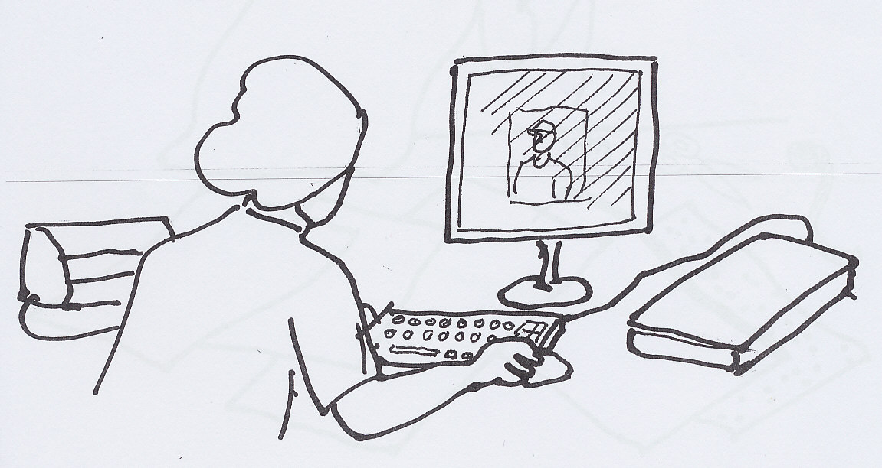

6. Choosing the basic cloth.
(Note that you need a different kind of transfer paper for light and dark cloth)

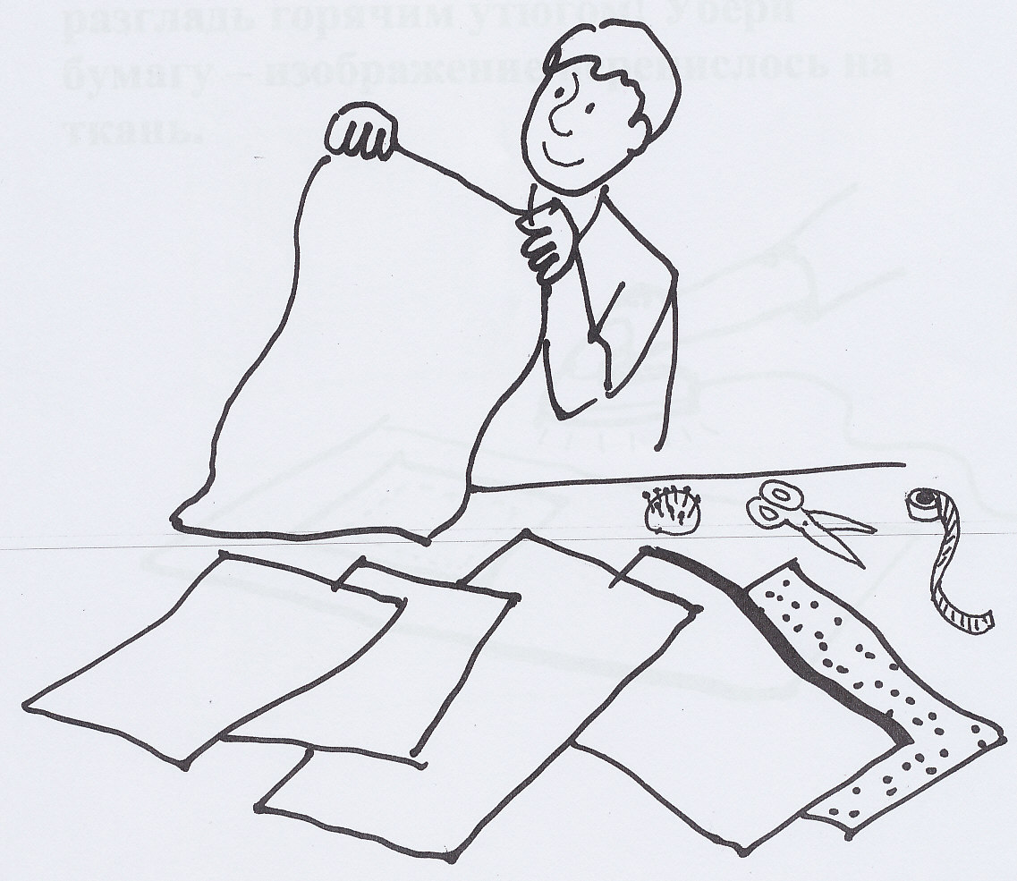

7. Place the paper on the right side of the basic cloth, backside up, and iron it with a hot iron! Take off the paper – the picture has been transferred on the cloth.

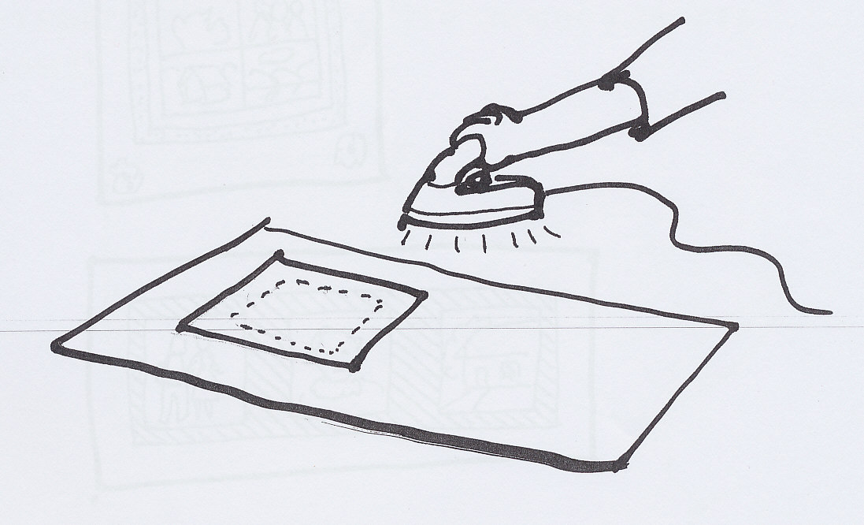

8. If you like you can decorate or frame the picture with pieces of cloth, ribbons etc.

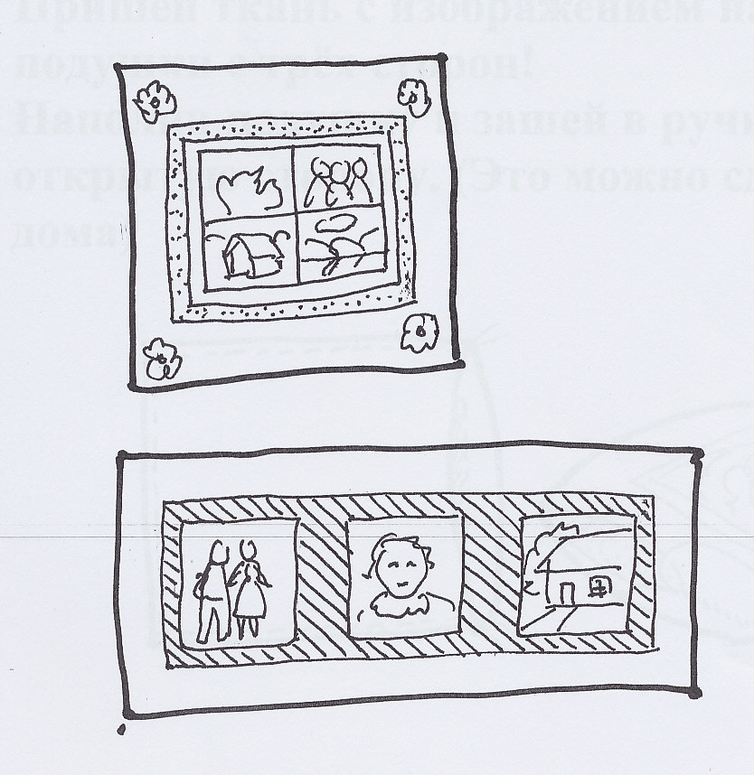

9. А. Completing: Memorial pillow

Sew the cloth on the back side into a pillow case on three sides!
Fill the pillow case and close (sewing by hand) the open side. (You can do this at home.)

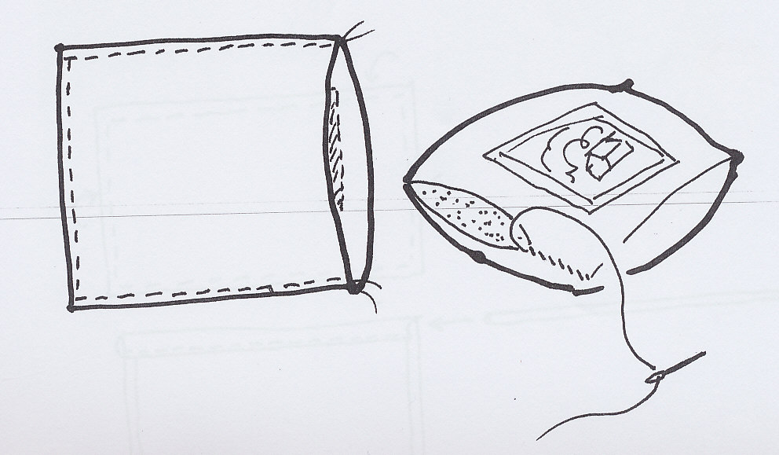

9. B. Completing: Memorial collage.

Fold the sides of the cloth on the back side and sew.
You can sew a piece of cloth on the upper side of the cloth to make an alleyway for a stick for hanging the collage on the wall. Or you can stretch the collage on a frame like a painting. (You can do this at home.)

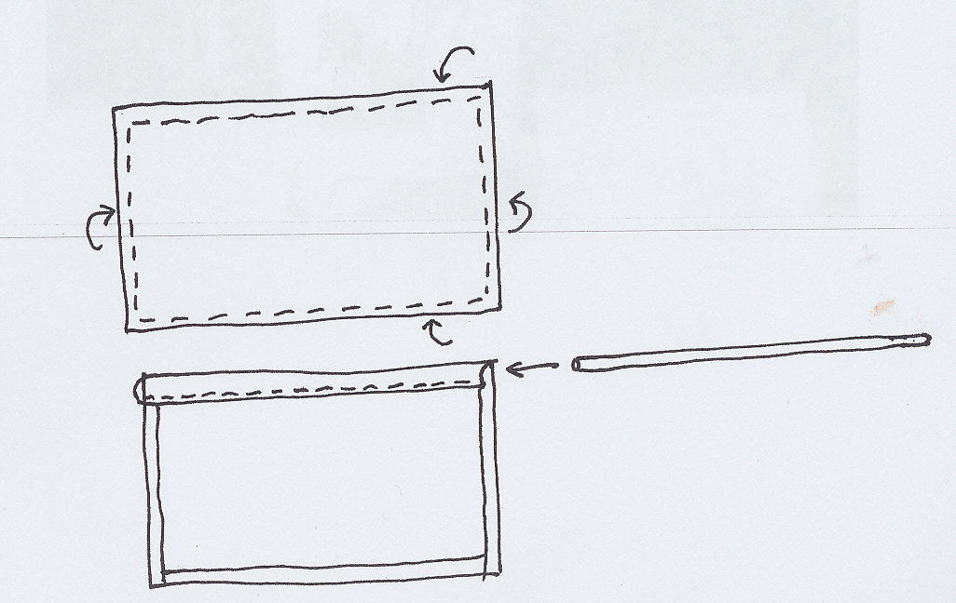

10. Completed!

